Comp_my_vs_Keld.doc
[1]. Sov. Phys. JETP 20, 1307 (1964), / ionization in the field of a strong electromagnetic wave. (Л.В. Келдыш Ионизация в поле сильной электромагнитной волны ЖЭТФ 1964, т.47, в. 5(11), с.1945-1957. (L.V.Keldysh Zh.Eksp.Teor.Fiz.47, 1945 (1964)).

[2]. J.R. Gulley Ultrafast laser-induced damage and the influence of spectral effects//Optical Engineering 2012, Vol. 51(12), 121805 8 pages).

Definitions.
A). – atom ionization rate calculated numerically under following assumptions:
- Hydrogen-like ion with ground state ionization energy , , (Z is ion charge) is assumed.
- Only ground state with wave function (, ) and states of continuum spectrum are involved in the interaction. Coulomb potential for states of continuum spectrum is not considered in Schrodinger equation. Ground state is assumed to be unperturbed (low degree of ionization)
- Ionization over long time is studied.

Equations (8), (9) from [1] are obtained as a result of assumptions above. (However, [1] apparently has a mistake: correct result should be 2 times higher than in [1]. It was mentioned by other authors as well) In this work, integrals (8) and (9) are calculated numerically. Thus, is obtained.

B). is ionization rate calculated approximately by saddle-point method. (eq. (16)-(19) in [1]).

C). is ionization rate , considering Coulomb interaction for continuum states (eq. (1) and (21) in [1]).

D). is ionization rate for a crystal (eq. (37)-(39) in [1]). Unlike for atom, is calculated per volume unit, not per atom, in [].

Case of atom. Comparison of and .

Assumption of Coulomb interaction.

After considering lost 2 in (8), (9) and correcting an obvious misprint in (16) ( instead of should be written) the formula for is as follows:

(1)

, (2)

(for )

or

(3)

The results can be found in my programs. Coefficients are not tracked during calculations, since it is assumed that they must be selected correspondingly to particular experiment. In order to express in terms of fs^{–1}, the value of obtained after my calculations must be multiplied by. The comparison of and formulas for obtained with saddle-point method in [1] for the wavelength 400 and 1030 nm, E_{g0}=9 eV is shown in figure 1. The x-axis represents value – logarithm of intensity in terms of W/cm^2. Intensity , where n=1.45 – is the refractive index, m=1/2 – is reduced mass expressed in the mass of an electron in vacuum. .

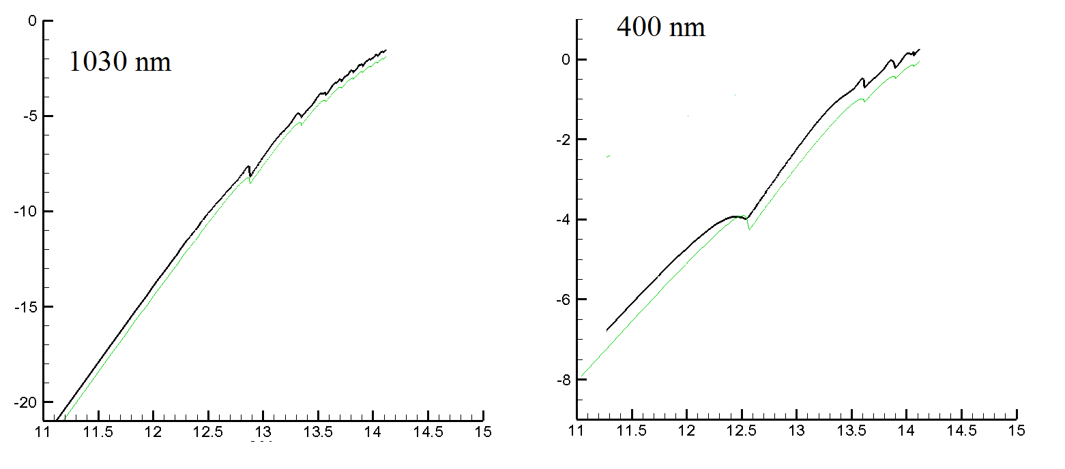

Fig. 1 – black curve, – green curve, x-axis:

The case for 800 nm is introduced more detailed in figure 2. Differences are not noticeable in logarithmic scale, especially in the regions of far from the points corresponding to vanishing of n-photon processes. Therefore values and are shown on the upper side of figure 2. Here differences between Keldysh’s and my results become more obvious. On fig 2a the value is also shown. It is necessary to take into account, that Keldysh theory has only logarithmic accuracy.

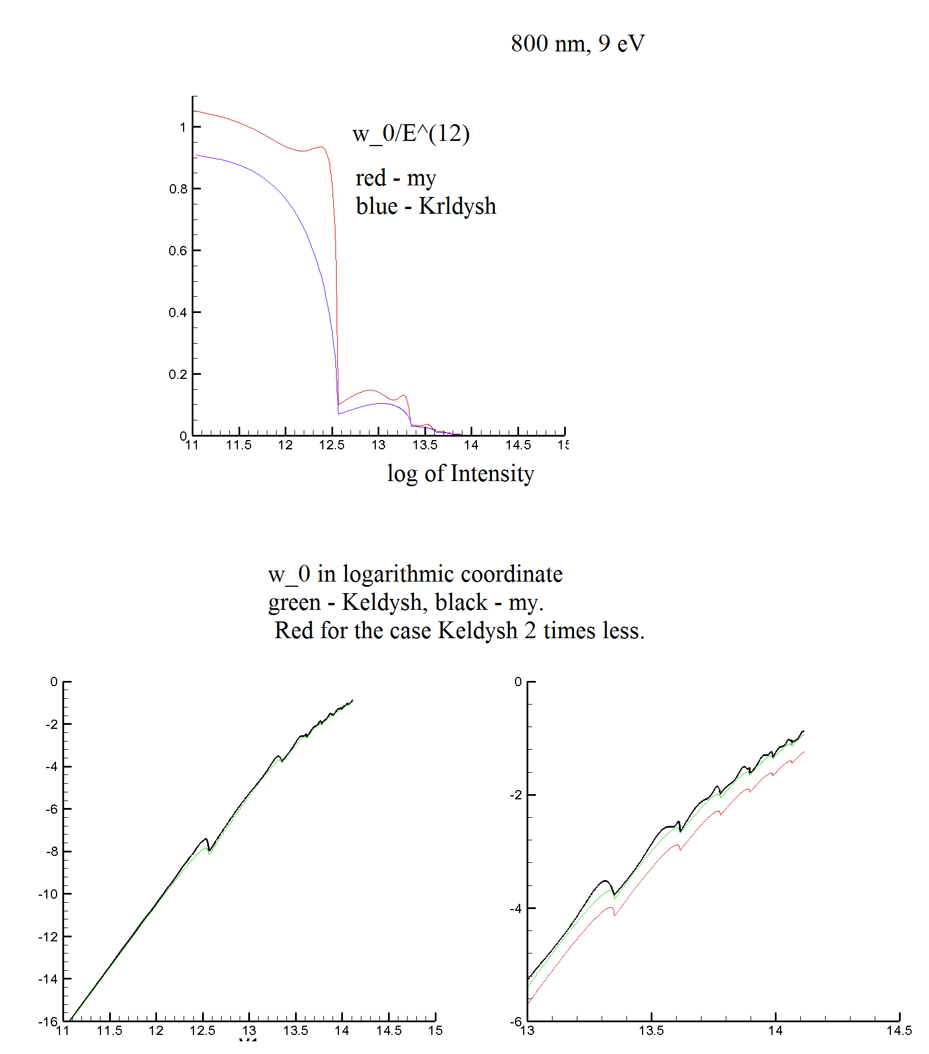

Fig. 2 Top plot: values (red) and (black) Bottom plots: (black) and (green), x-axis: .

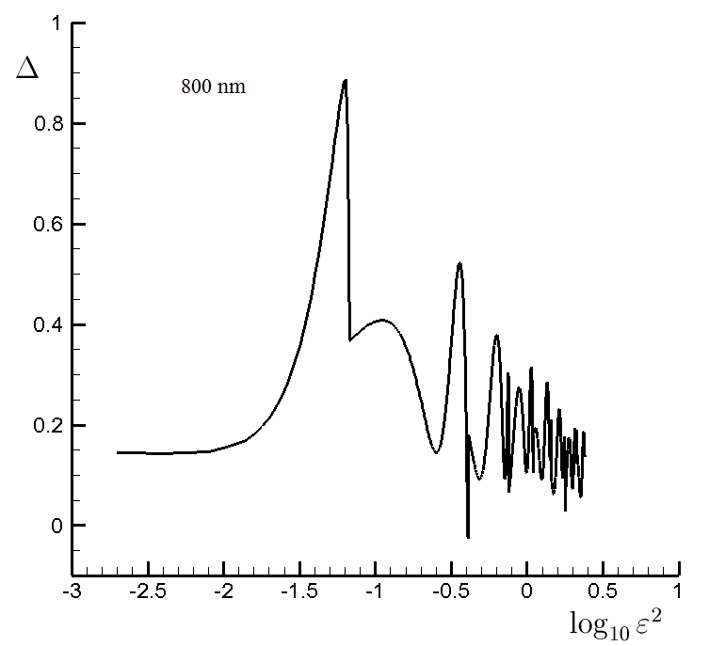

Fig. 2a. The value for 800 nm, E_{g0}=9 eV.

I will make a number of important observations.
- Keldysh’s article specifies that developed theory is only applicable for . In our case this value is =6 (for fused silica) or less (for silicon).
- In Keldysh’s and this work, matrix element of hydrogen-like ion is used. The real matrix element may be different. The statement about weak dependency of the result on the matrix element in Keldysh's article is technically connected with use of saddle-point method, which will be used is case . In our case this inequality is often not fulfilled.
- As stated before, developed theory doesn’t consider Coulomb interaction. Keldysh states that for taking this effect into account it is sufficient to multiply obtained result by

(4)

Here A is a coefficient in the order of 1. As a result in Keldysh’s work the final formulas (1) and (21) are obtained. The first is as follows:

(5)

In cases of our interest , the value of (4) is 5 and is weakly depending on field.

Limited by low fields (, multiphoton ionization) for atom from (5) we have

, (6)

And considering a factor in the order of magnitude of (4)

(7)

Generally, developed theory is very approximate. It is noted in Keldysh’s work that “Pre-exponential factor… needs to be clarified, however all dependencies are defined by exponents. Thus, coefficient of obtained formulas can be taken as an adjustable parameter, which is determined experimentally.

We shall notice that factor (4) depends on frequency and in case of a two color pulse is difficult to determine. However, in a two color pulse frequencies don’t show bigger discrepancies than a factor of 2. That means for different ratios between wave amplitudes contained in a dichromatic pulse, the coefficient can vary only by amount in the order of unity. However, typically in two color pulses frequencies differ not more than of a factor of two. Such details can be neglected considering the proximity of obtained formulas.

Case of crystal

References to elliptical integrals.

,

.

или

Through Legendre formula

We get

can be calculated as follows. Let’s consider the sequences , for starting values, . Then for such n, when we have .

In [1] semiconductor (crystal) deviates from the case of atom discussed above by relation between impulse and energy. For crystals this relation is:

(6)

In the case of small pulse amplitude, we have

(7)

Moreover, electrons interact with the lattice (with many atoms) in a crystal. Therefore, unlike in the case of atom, ionization probability per volume unit rises in crystals. Qualitatively dependency of on pulse energy holds as showed at fig. 1,2.

In case of crystal, for small amplitudes according to Keldysh: (formula (39) of Keldysh is misprinted. Instead of , had to be printed. It is corrected in Gulley paper. To obtain the formula (41) of Keldysh paper must be 4 instead of 2 also. This had been cheked^ coincidence with Gulley)

(8)

Plot from Gulley’s work and results of my own calculations multiplied by density are shown in fig. 3. Considering approximation of formulas, very good correspondence can be seen. Note that the transition from n-photon to n+1-photon ionization occurs at higher intensities in case of atoms than it is the case for crystals, as must be according to (7). Note also that in case of crystal dependency of energy on pulse can differ from (6) (Gruzdev). This fact introduces additional arbitraries to formulas.

We emphasize that value can be interpreted as probability of one atom ionization multiplied by an effective density of atoms. The effective density of atoms is not directly connected to real density of atoms in a crystal. This is because the behavior of an electron in a crystal is determined by the interaction with the entire lattice (many atoms). It is impossible to single out one atom.

Note that fused silica is not a crystal. Thus, technically speaking crystal theory can’t be applied. On the other hand, density in fused silica is very high. Hence, atoms can’t be considered as isolated from each other.

Conclusions

The main conclusion of this work is that for values in the range of interest and not exceeding , the results of the different models (atom and saddle-point method for integral value calculation (Keldysh) and precise integral calculation (current work, Keldysh’s theory for crystal)) are very close. Considering multiple assumptions, the differences between results are insignificant. Thus, the simpler model for photoionisation can be used, for example for further development of photoionisation theory for two color pulses. Wherein a coefficient, which is determined from comparison with experimental results or from calculations based on initial principles, must be introduced. The electron’s mass must be considered as adjustable parameter as well.

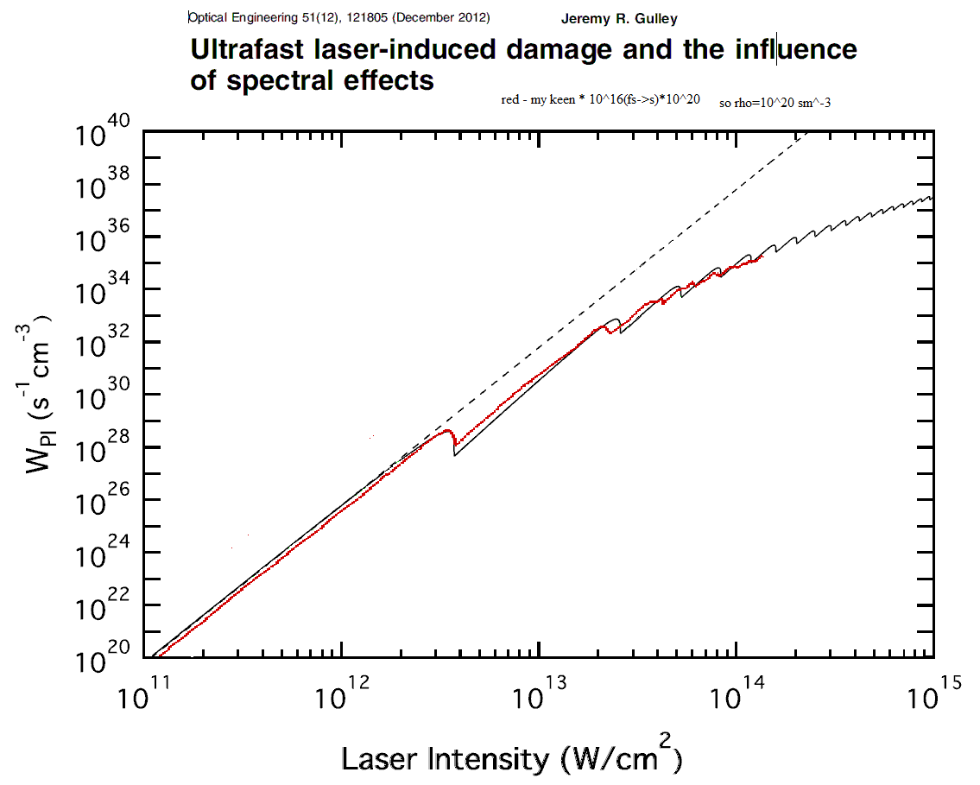

Рис. 3 Red curve: , black curve: , from Gulley’s article

The radiation wavelength is much longer than size of the atom. Thus, the electrical field depends only on time and is defined as follows:

,

Where states for first and second harmonic, which are polarized along constant vectors . Some of following calculations can be performed for time-depended amplitudes. Thus, time dependence of is still considered. Harmonics can be shifted by phase . The main results are obtained for const. In [1] the case of const., is considered.

To make a clear overview, all values are normalized as follows. Distance will be measured in terms of and time in , where is the ground state energy; frequency will be measured in , electrical field in Keldysh’s units . Thus, the electrical field of each component is normalized on its own value. Then the dimensionless quantities will be used instead of electrical fields. Hence, the Schrödinger equation for a continuous spectrum function takes the form:

,

,

, , ,

,

,

Considering and .

We define ,

For constant field amplitude characteristics , and solution is:

In Keldysh, characteristics have +. Obviously, .

Determination of

1. found by myself. If

, (1)

Then as expected.

2. 2 - according to Keldysh. It seems that multiplier 2 was abandoned in Keldysh’s work. In case (1) , thus oscillating! Keldysh expanced in Fourie series without electric field . This is why is present there.

We will keep 1st definition.

After is introduced, and time is defined in terms , and frequency in we have

Or

will be expanded into Fourier series. Then,

If and then

Terms with and/or contribute to as

The integrand has no singularities. Hence, the integral will be calculated as principal value after expanding brackets in numerator and representing denominator as . Principal value of integral 1/x is finite. Principal value of doesn’t increase with time. Thus, terms with and/or contribute to with a damping term.

Thus,

сек.
(14)
(15)
For internal demonstration. In programs (for example keldu5.for) unnormalized ionization speed equals to (multiplied by 2 if calculated from (–pi/2) to pi/2).
Then
(16)
Considering numerical coefficients in (5) .

For 9 eV and density of atoms the coefficient to multiply keldformax.dat .

According to calculation for 9 eV 800 nm integral is ,thus . For density of atoms coefficient is .

(3)
Solving (3) in an usual way with characteristics in k space with zero initial data we have
(4)

,

Atom, after saddle point.

In Keldysh’s work as well as in mine, formulas (16) and (18) are obtained after calculating the integral value with saddle-point method. Those formulas can be handled better after rewriting them as (16) contains misprint: instead of expression had to be written)

Or

The radiation wavelength is much longer than size of the atom. Thus, the electrical field depends only on time and is defined as follows:

,

Where states for first and second pulse, which are polarized along constant vectors . Some of following calculations can be performed for time-dependent amplitudes. Thus, time dependence of is still considered. Harmonics can be shifted by phase . The main results are obtained for const. In [1] the case of const., is considered.

To make a clear overview, all values are normalized as follows. Distance will be measured in terms of and time in , where is a ground state energy; frequency will be measured in , electrical field in Keldysh’s units . Thus, the electrical field of each component is normalized on its own value. Then the dimensionless quantities will be used instead of electrical fields. Hence, the Schrödinger equation for the continuous spectrum function takes the form:

(1)

, (2)

Where is the wave function of ground state. The factor is insignificant, since coefficients of obtained speed of ionization values will be determined correspondingly to an experiment. It is only important that constant is independent on parameters of the electromagnetic wave, mainly on its frequency. Function doesn’t have component along in space of functions, since . This fact was taken into account in (1). After Fourier transform in (1) we get
(3)
After solving (3) in an usual way with characteristics in space with zero initial data we have
(4)
, (5)
Since our main interest is dependence of , then factors of type, () in front of integral (4) are not important. Integral over in infinite limits is equal to integral over . Then we have
or
(6)
In case of constant pulse
(7)
Then (6) becomes
(8)
(9)
Terms independent on time (const in (8)) in exponent can be separated from the integral over time in (6) and can be neglected. Denoting
(10)
Thereafter,

2. Calculation of ionization speed in case of irrational ratio .
In case of an irrational relation the functionwill be expanded into double Fourier series in terms of and as follows:
, (11)
We note that functions and are periodical functions of variables and . Consider the function of two variables after replacing with and with in term:
.
Function is periodic with period of for both variables. We expand it into a double Fourier series as . Obviously, and
(12)
Then
(13)
We define average ionization speed over long time as . Considering usual limit representation of -functions as imaginary exponentials up to unimportant factors we see that only series terms with , are left in (13) and
(14)
It is obvious from (12) and (14) that phase doesn’t affect the results, thus its value can be set as 0. Indeed, replacing in (12) leads to multiplication of by , which doesn’t affect .
Using cylindrical coordinate system with axis and defining , from (13) we have
(15)
(16)
(17)
Here, is a numerical factor independent on wave parameters. This factor must be determined after comparison to experiment.
Delta function in (14) and (16) has clear physical meaning. The energy of n quants from wave with frequency and m quants from a wave with frequency is used to overcome ionization potential (equals to 1 in chosen units), given to a free electron by an average energy of oscillation in first wave and in second wave and the energy of translation movement. Value represents the speed of-photon ionization. - photon ionization is not possible, if the energy of corresponding amount of quants is not sufficient for overcoming forbidden band (ionization potential) and providing average oscillation energy (). In other words, in case of sufficiently high field amplitude. Dependency of ionization speed on wave amplitude shows a local decrease of (fig. 1).
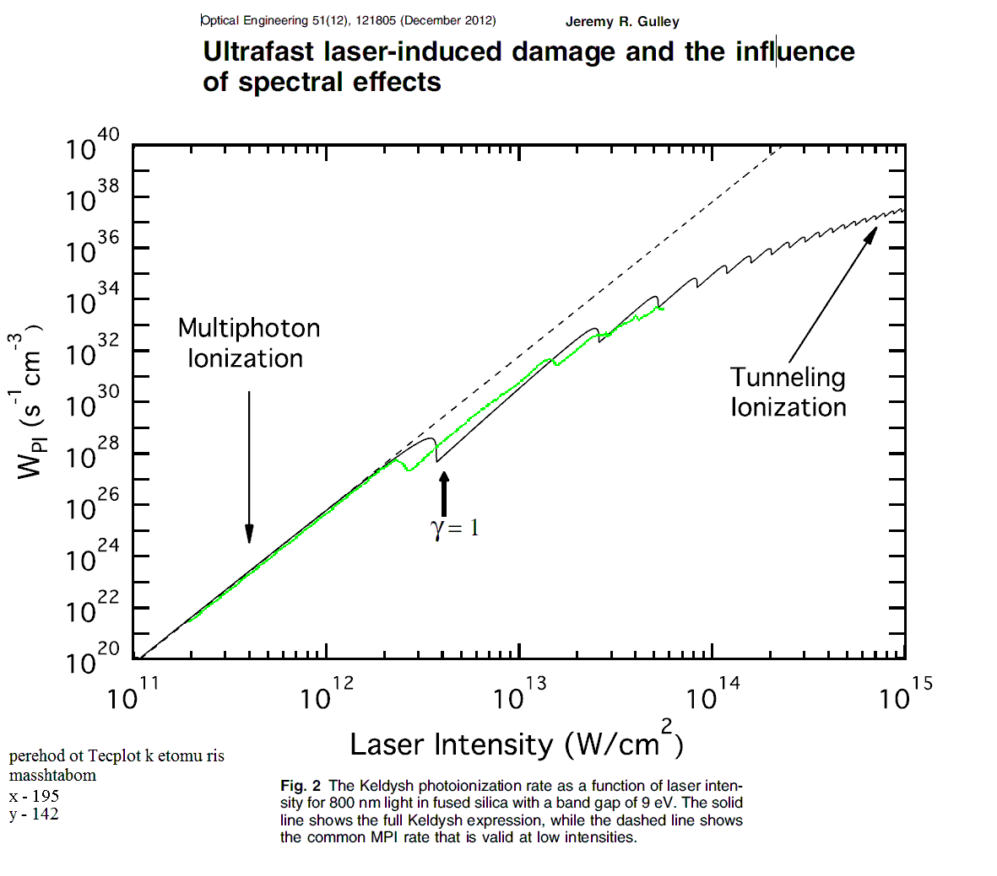
Fig. 1 Dependency of ionization speed on monochromatic laser wave intensity according to [14] and in current work. Details can be found in sec. 6. Thibault this is old version which is not good! Don’t pay attention.

3. Calculation of ionization speed in case of rational .
If for frequencies and exists a frequency and integers and , so that , (the fraction is considered as irreducible), then expansion into single Fourier series over frequency must be used instead of (11). In case expansion into double Fourier series (11) is used, first terms with same must be summarized, and then the absolute value must be summarized over all possible values : . The first method of ionization speed calculation is faster for small . Otherwise the method using double Fourier series and summarizing with equal is faster. In latter case pairs of numbers and , which result into same number , are separated from each other by very large distance . Since noticeably differs from 0 in restricted area of space , formulas for irrational can be used instead of mentioned summarization for large .
Already for the differences between calculation of using formulas for irrational frequencies ratio and formal usage of formulas for irrational frequencies ratio are low. (Tab. 1). We emphasize that the phase doesn’t play a role anymore in case of irrational frequency ratio. However already for frequency ratio 2/1 moderate dependence on phase can be observed (Tab.1). With further increase of and the mentioned dependence disappears.
Tab. 1. eV, =0.8 um, =0.4 um, . А and Б – calculation by formulas rational frequencies ratio for and respectively; В –formal use of formulas for irrational ratio; Г – case of =0.8 um, =0.41 um. Dependence on phase is not present. Result is equal to one obtained with formal use of formulas for irrational .
 | А | .20993
 | Б | .21367
 | В | .212655
 | Г | .195
 | А | .300
 | Б | .33941
 | В | .315
 | Г | .299

The case of equal frequencies and is equivalent to a case (linearly polarized monochromatic pulse) and only differs by polarization direction. The case of , and corresponds to circular polarization. Calculations show that for the same wave energy (same value ) the speed of ionization is bigger in case of linearly polarized waves than for circularly polarized waves. This fact corresponds to experimental data. For example, for wavelength 0.8 , eV, ratio of for a linearly polarized wave compared to of a circularly polarized wave is 1.24/0.234.
We note that in [11] the analogical qualitative dependencies of ionization speed on wave polarization for substantially different pulse parameters were obtained.
We further note that a real pulse has a width. Thus, it might be more correct to the formulas for irrational frequencies ration.

4. Energy absorbed during ionization
In case of is irrational, the energy absorbed from first and second wave is and respectively, based on above-mentioned physical meaning of (14) and (16). In dimensional form, one multiplies by (). In case of is rational, the total energy absorbed from both waves can be easily calculated. However, it is not known how this energy is distributed between waves. Considering remarks made in chapter 3, formulas for irrational frequency ratio may be apparently used.
We will discuss some details of the model for describing the interaction between two color laser pulses with glasses. For a pulse length in the order of tens of femtoseconds it is suitable to use complex amplitudes to represent electric field, current and other quantities. For example, real electric field can be represented as ( is number of a wave in pulse). This representation is necessary, since in many formulas of the model (for example, for Kerr effect) the complex amplitudes are used. Additionally, it simplifies the problem of numerical equation solving, since time of change is significantly longer then . Maxwell equation (in CGS) for electric field will be as follows:
(18)
Where , and are complex amplitudes of induction vector, speed of free electrons and magnetic field respectively, is a density of free electron plasma, is an elementary charge, is energy absorbed during photoionization, is number of wave in the pulse. For the electron velocity and density following equations are used:
(19)
(20)
Where is a mass of free electron, is the collision time with the lattice (phonons), is the rate of other ionization-recombination processes (for example, impact ionization). In hydrodynamic equation (19) the terms with electron pressure and are omitted. Those terms are insignificant for our calculations.
In many cases, a simpler equation can be used instead of (19):
(21)
The last term in (18) is arranged in such a way that while deriving the energy conservation law for electromagnetic energy, is subtracted from energy. Let us find the ratio between and . We note that in case the variation of complex amplitudes is slow compared to wave frequency, equations (18) - (20) provide subtraction of average electron oscillation energy in a wave (in dimensionless units of previous chapters ) from energy of electromagnetic field. This subtracted energy is already taken into account in Keldysh’s theory, in the expression for. Thus, in case of equations (18)-(20), must be set. In equations (18) and (21) mentioned energy is not subtracted, since (21) corresponds to steady oscillations. Thus, must be set.
We note a sharp increase of absorbed energy while transferring from multiphoton ionization regime with small wave amplitudes to tunnel regime. In fig.2, the amount of absorbed quants per electron versus intensity is shown. In analogy to the article [14] the intensity of a light wave (for a given electric field in a wave) in vacuum, rather than in glass is understood under the term intensity. The case of fused silica ( eV) with electron (polaron) mass equal to half of electron mass in vacuum and monochromatic wave at 800nm is introduced.
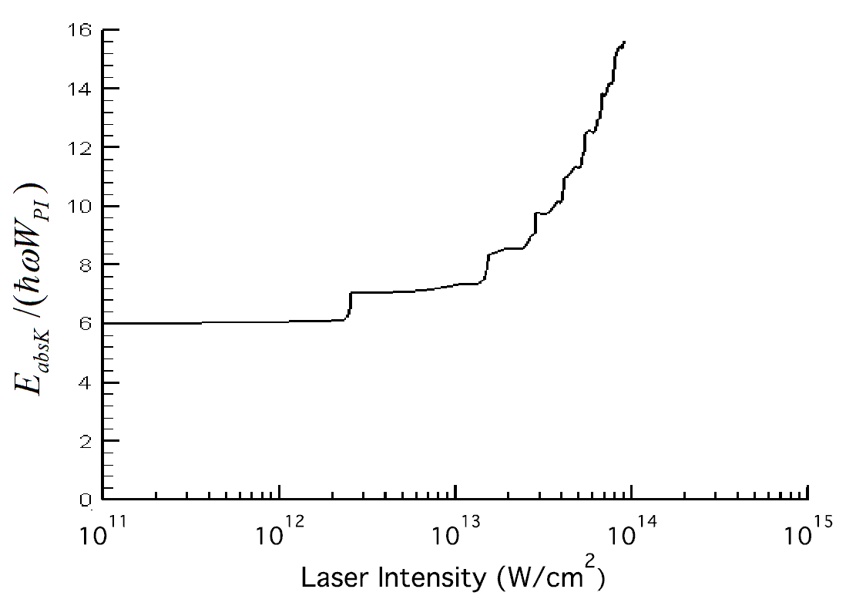
Fig. 2
We also note that for fused silica and a wavelength of 800 nm, at minimum 6 quants are needed for ionization. However, for such low intensities, that there is no glass modification anymore, the frequently used equation for 6 photon ionization stops to be valid.
5. Integration method while calculating ionization rate
In [1] integration is carried out by the saddle-point method. In current work, numerical methods for integrals and sums in (12), (15) and (17). Such calculation requires significant computational resources. Range of m and n, used during summation, is chosen in a way that the result does not change significantly with further increase of series terms. To evaluate fast oscillating integrals of form
The following method was used. The integration range is divided in segments , , . In segments F is approximated by quadratic polynom:
The exponent is represented in the form
Then
where . Integration in those expressions can be easily carried out analytically.
Integration over and was made with rectangle method (, ) or Simpson’s rule. The number of grid points was selected experimentally. Calculations show that Simpson’s rule is more suitable for integrating over . 30 grid nodes are sufficient to bring error below 1%. In many cases, rectangular method converges faster than Simpson’s rule while integrating over. Besides, the result doesn’t change at 10-s decimal place with further increase of already for small amount of grid nodes . A possible explanation of this can be as follows.
The quantity is a function of and а is a function of . The latter statement is based on some amount of calculations, but hasn’t been proved analytically. Correspondingly, the quantity is expanded into a series of the form , and . Rectangular method gives . Thus, the error of rectangular method is defined by high number harmonics. The error of calculation of by Simpsons rule is defined by with , multiplied by a grid step in the power of 4. The better convergence of rectangle method might be due to the fact that decreases rapidly (for example, exponentially or as to the high power) with increase of .
For completeness, we note that , are apparently the even functions of . This is also not proven analytically. In order to avoid errors, calculations were carried out over whole range of and , without taking possible symmetry into account.

6. Difference between crystal (semiconductor) and atom in Keldysh theory.
The theory of photoionization for atom and crystal is developed in [1]. The difference between those cases is basically only in a dispersion law. For a crystal, energy depends on an electron-hole pair pulse p as follows: [1]
(22)
While for atom holds, where is electron mass in medium, is a reduced mass of electron and hole. In the low-intensity limit, dispersion law for a crystal becomes an expression for an atom, but with reduced mass. In case of a crystal, the expressions similar to (11)-(17) for ionization rate appear. There, (average over period) figures instead of average oscillation energy , where the impulse is determined from equation .
Fused silica is an amorphous body. Therefore, Keldysh’s photoionization theory for an atom is more suitable than theory of photoionization in a crystal. Nevertheless, we investigate differences between atom and crystal for a monochromatic wave for completeness.
Fig. 1 shows ionization rate versus wave intensity in vacuum for a crystal from [14] and calculated by formulas from current work. In [14] ( is electron mass in vacuum). is set in (11)-(17) to achieve a good agreement with the case of amorphous body in a low intensity limit. The corresponding coefficient is adjusted as well.
increases slower than in (22). Hence, for such intensities, for which n-photon ionization finishes in case [14], ionization rate drops later. However, one must note that dependencies are not only qualitatively similar, but as well quantitatively. Considering imperfections of Keldysh’s theory while describing fused silica (see below) as well as uncertainties of formulas describing other processes during laser pulse and glass interaction (impact ionization, the frequency of collisions of free electrons and atoms etc.), those differences are not significant. Additionally, dispersion relation (22) is as well imperfect [15-18].
We note one more difficulty in use of (22) for describing femtosecond pulse with matter interaction with equations of type (18) - (21). In this case carrier velocity in expression for flux will be nonlinearly related to impulse: . This leads to harmonics generation and difficulties with carrier frequency separation.
Thus, the following can be proposed. While developing the model of femtosecond pulse interaction with dielectrics, the electron mass contained in should be considered as a parameter. That parameter should be adjusted after comparing to an experiment.

7. Calculation results
Some important results of calculation:
For large wave amplitudes, when , corresponding ionization becomes impossible (). On plots of ionization rate versus wave amplitude (fig.1) a local decrease of can be observed. For fused silica that is important for practice (forbidden band =9 eV) and wavelength 800 nm (monochromatic pulse) the smallest n at which is equal to 6. However, according to experiment, 6-photon ionization condition stops to be valid for amplitudes too small to cause glass modification. Thus, frequently used formula for multiphoton ionization is only applicable as rough guess. The sums (15) with large amount of terms must be used. We also note that absorbed wave of electromagnetic wave per electron also increases with wave amplitude (fig.2) Thus, it is incorrect to use constant value for absorbed energy per electron (for example or ).
Calculations show that the rate of ionization by two color pulse is mostly significantly higher than total rate of ionization by two separated pulses of same amplitude: (fig.3). The values for which decreases can be exception (, ).
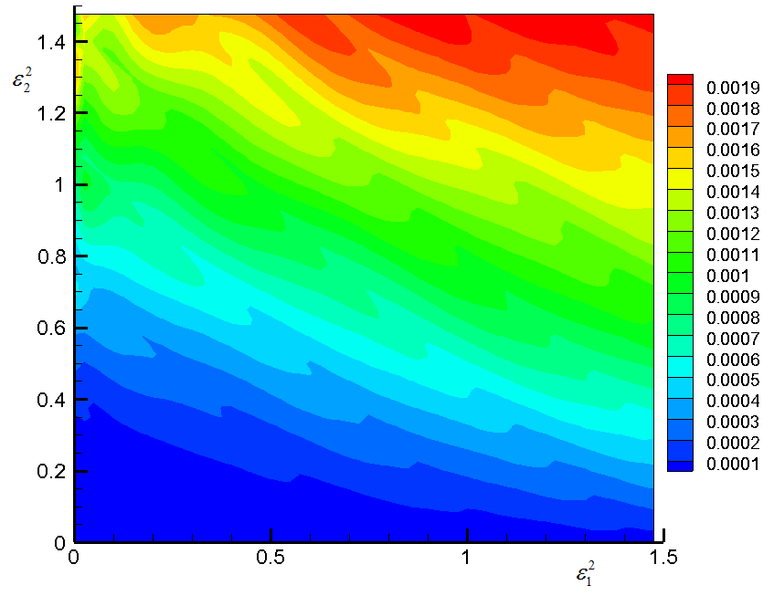
Fig. 3. versus squared dimensionless wave amplitudes in two color pulse in case of irrational frequencies ratio. Wavelengths 800 and 401 nm.

Ionization rate in case of two color pulse with same polarization waves () is higher than in case of perpendicular polarizations . Particularly, this was demonstrated for monochromatic wave with circular polarization that can be considered as two color pulse with , same frequencies and phase .
At high fields it can happen that energy of one wave is enough for ionization and second wave for amplification. For example, in case of waves with same polarization () with 800 and =401 nm, dimensionless amplitudes =1.8, =0.1 first wave loss is per electron. The second wave obtains energy . Those results are obtained for irrational frequency ratio. We note that the use of code for rational frequency ratio in this case results into same ionization rate. However, one cannot distribute pulse energy loss between waves. Distribution of W_{nm} in this case is shown at fig. 4. For value is only for m=0, and for – for n=0.

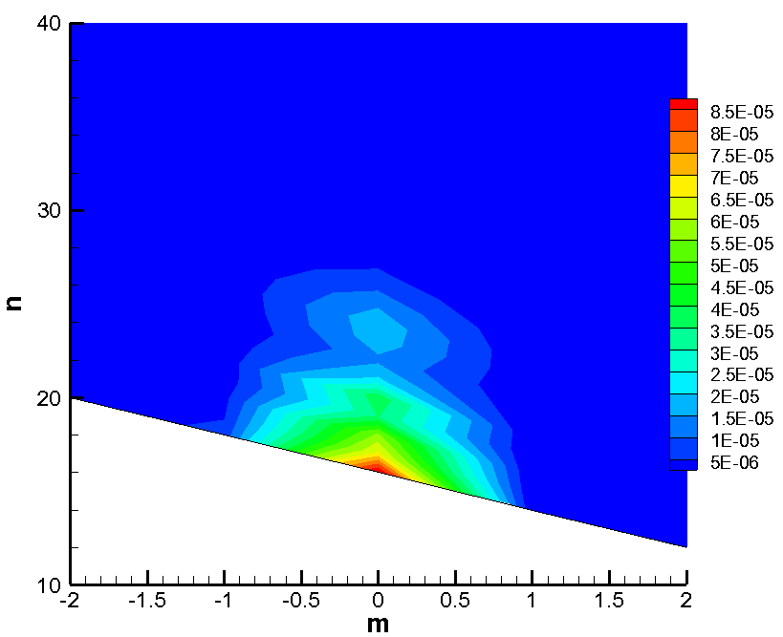
Fig. 4 distribution. Pulse parameters are listed in chapter 7.
8. Model disadvantages
The Keldysh model of photoionization and its generalization, developed in current work has following disadvantages:
- Free electron for a long period (compared to a wave period) is considered as unaffected except of by mentioned wave. This is not valid in case of fused silica. Collision frequency is comparable to wave period. However, for big amount of collisions, impact ionization starts to play a significant role and photoionization is not significant.
- Time for amplitude change must be much higher than wave period. For pulse length around tens of femtoseconds, amplitude change in a given position can happen much faster (<10 fs) thanks to fast change of plasma density. Thus, wave period value is lying in short range.
- Dependence of conducting electron impulse on its energy can differ from proposal in [1]. This can significantly affect the result. [Gruzdev].
To some extent, those disadvantages can be leveled by the fact that in many practically important cases photoionization acts as fuse. Most of conducting electrons are produced after impact ionization. We note that while describing impact ionization many problems arise. Thus, the model developed in current work and original model in [1] must be considered as semi phenomenological model and included coefficients as parameters which must be determined after comparison to an experiment.

9. Conclusion
The Keldysh theory for photoionization in a solid body (dielectric, semiconductor) is generalized for a two-color laser pulse in current work. Many interesting and important results are obtained and explained in chapter 8.
We emphasize the complexity, variety and interrelation of processes behind laser and matter interaction. As a result, equations describing different processes during interaction are connected to each other. Particularly, current work shows that the term describing electron absorption due to photoionization in Maxwell’s equation depends on the type of equation used for conduction electron velocity. Technically, dispersion law (relation between energy and impulse of conducting electron) used in photoionization theory must correspond to equation for electrons movement in hydrodynamic part of model for Maxwell’s or Schrödinger’s nonlinear equations. The fully correct mathematical description of investigated effects is very complicated, obviously not possible and maybe even not needed. One must create simple semi phenomenological models that consider basic process properties with parameters determined after comparison to experiment. Results of current work are first of all relevant for fused silica, but may be also applicable to other materials.
Current work was financially supported by Russian Fund for Fundamental Research (РФФИ) as part of scientific project № 15-01-02432.

Figure. 1. as a function of squared dimensionless wave amplitude in two color pulse in case of irrational frequencies ration. Wavelengths are 800 and 401 nm.

[1] Келдыш Л.В. Ионизация в поле сильной электромагнитной волны // ЖЭТФ. 1964. Т. 47, в. 5(11), С. 1945-1957.
Keldysh L.V. Ionization in the field of a strong electromagnetic wave // JETP. 1964. Vol. 20. P. 1307-?.
2. Bulgakova N.M., Zhukov V.P., Meshcheryakov Yu. P., Gemini L., Brajer J., Rostohar D., Mocek T. Pulsed laser modification of transparent dielectrics: What can be foreseen and predicted in numerical experiments//Journal of the Optical Society of America B. 09/2014 31(11):C8-C14. DOI: 10.1364/JOSAB.31.0000C8.
3. Bulgakova N.M., Panchenko A.N., Zhukov V.P., Kudryashov S.I., Pereira A., Marine W., Mocek T., Bulgakov A.V. Impacts of Ambient and Ablation Plasmas on Short- and Ultrashort-Pulse Laser Processing of Surfaces// Micromachines. 2014. Vol. 5, P. 1344-1372.
4. Bulgakova N.M., Zhukov V.P., Collins A., Rostohar D., Derrien T.J.-Y., Mocek T. How to optimize ultrashort pulse laser interaction with glass surfaces in cutting regimes? // Appl. Surf. Sci.. 2015. Vol. 336. P.364-374.
5. Bulgakova N.M, Zhukov V.P., Sonina S.V., Meshcheryakov Yu. P. Modification of transparent materials with ultrashort laser pulses: What is energetically and mechanically meaningful?//J. Appl. Phys.. 2015. Vol. 118. No. 23. Paper 233108 (17 pages)
6. Bulgakova N.M., Zhukov V.P., Mirza I., Meshcheryakov Yu.P., Tomáštík J., Michálek V., Haderka O., Fekete L., Rubenchik A.M., Fedoruk M.P., Mocek T. Ultrashort-pulse laser processing of transparent materials: insight from numerical and semi-analytical models//Proc. SPIE 9735, Laser Applications in Microelectronic and Optoelectronic Manufacturing (LAMOM) XXI, 97350N (March 14, 2016) (16pages).
7. Mermillod-Blondin A., Rosenfeld A., Stoian R., Audouard E. Formation dynamics of femtosecond laser-induced phase objects in transparent materials//Proc. Of SPIE 2012. Vol. 8247, 82470Q(1-7).
8. Zhang F., Teng Y., Yu Y., Sharafudeen K.N., Hirao K., Qiu J. Formation and applications of periodic structures in transparant materials induced by single fs laser beam//Optical Society of America (Optical materials express. 2013. Vol. 3, No 11. P.1944-1951.
9. Schmitz H., Mezentsev V. Full-vectorial modeling of femtosecond pulses for laser inscription of photonic structures//J. Opt. Soc. Am. B. 2012. V. 29, No 6. P. 1208-1217
10. Potemkin F.V., Bravy B.G., Bezsudnova Yu I., et all Overcritical plasma ignition and diagnostics from oncoming interaction of two color low energy tightly focused femtosecond laser pulses inside fusied silica//Laser Phys. Letters. 2016. Vol. 13. 045402c(8pp).
11. Котельников И.А., Бородин А.В., Шкуринов А.П. Многофотонная ионизация атомов двухцветным лазерным импульсом//ЖЭТФ. 2011. Т. 139, в. 6. С. 1081-1087.
Kotelnikov I.A., Borodin A.V., Shkurinov A.P. Multiphoton ionization of atoms by a two-color laser pulse//JETP. 2011. Vol. 112, No 6. P. 946-951.
12. Burakov I.M., Bulgakova N.M., Stoian R. et al. Spatial distribution of refractive index variations induced in bulk fused silica by single ultrashot and short laser pulses//J. Appl. Phys. 2007. Vol. 101. Paper 043506 (7 p.).
13. Couairon A., Sudrie L., Franco M. et al. Filamintation and damage in fused silica induced by tightly focused femtosecond laser pulses // Phys. Rev. B. 2005. Vol. 71. Paper 125435 (11 p.).
14. Gulley J.R. Ultrafast laser-indused damage and the influence of spectral effects//Optical engineering 2012. Vol. 51(12) p.121805.
15. Gruzdev V.E. Modeling of laser-induced ionization of solid dielectrics for ablation simulation: role of effective mass // Proc. of SPIE Vol. 7842, 784216(1-11) [CCC code: 0277-786X/10/$18 · doi: 10.1117/12.869760]
16. Gruzdev V.E. Photoionization rate in wide band-gap crystals // Phys. Rev. B. 2007. Vol 75. 10510(1-13)]
17. Gruzdev V. How the laser-induced ionization of transparent solids can be Suppressed // Laser-Induced Damage in Optical Materials: 2013, edited by Gregory J. Exarhos.
18. Gruzdev V.E., Menapace J.A., Ristau D., Soileau MJ., Proc. of SPIE 2013. Vol. 8885, 88851S ·(1-12) doi: 10.1117/12.2031805

